Northern Suburbs Football Association
Under 12
Midi – field information

When setting up fields please be mindful of the following safety parameters.
All goals must be secured to the ground, ideally using sandbags. If using pegs please be sure to remove these after use as they cause damage to grass mowers.
Midi fields must be set up at least 6m apart. Each field is required to be 3m from any obstacle such as fences, team benches, opposition players etc..
Technical areas are only accessible to players, coaches, managers and officials. Parents MUST stand in the spectator zones unless specifically asked to enter the Technical Area to support by the team manager.
Creating a positive learning environment for our players. It is the responsibility of coaches, managers and spectators to create a positive learning environment for ALL players. Please be mindful of what you say, how you act and your approach to matchday. Together we can create a great playing environment.
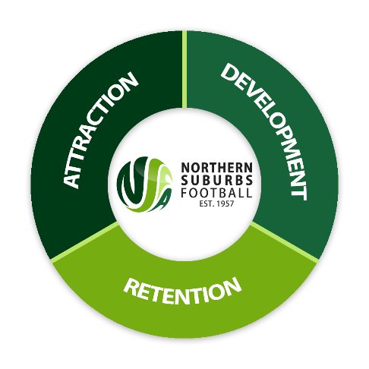

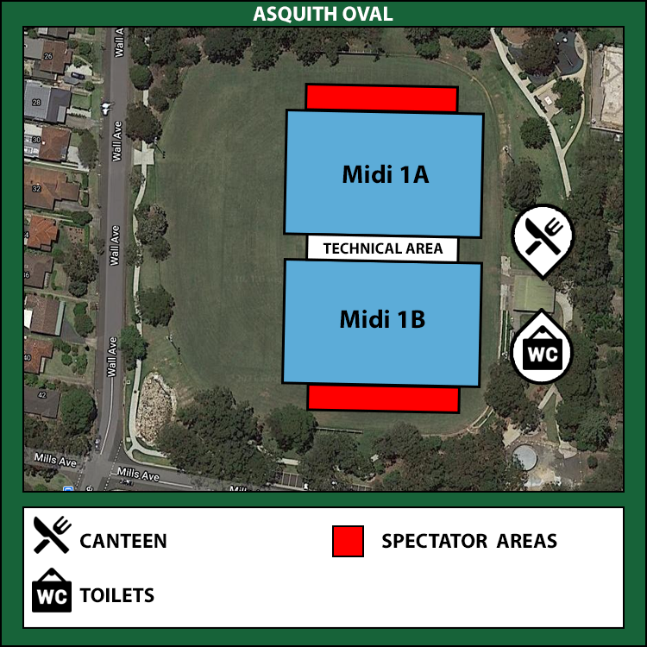

Full field dimensions | 100m x 72m
Midi field dimensions | 67m x 42m
Goal type | Portable goals – Bownets
Club responsible | Asquith FC

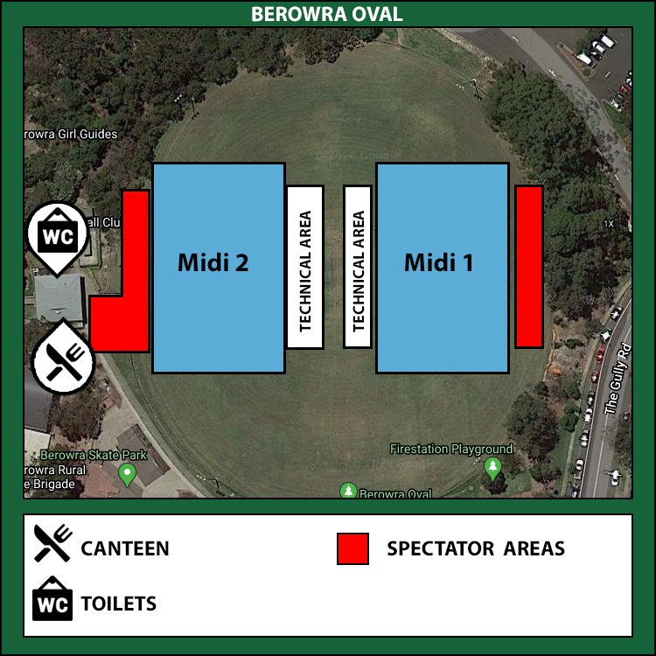

Full field dimensions | 102m x 69m
Midi field dimensions | 69m x 44m
Goal type | Portable goals – Bownets/Aluminium
Club responsible | Berowra FC

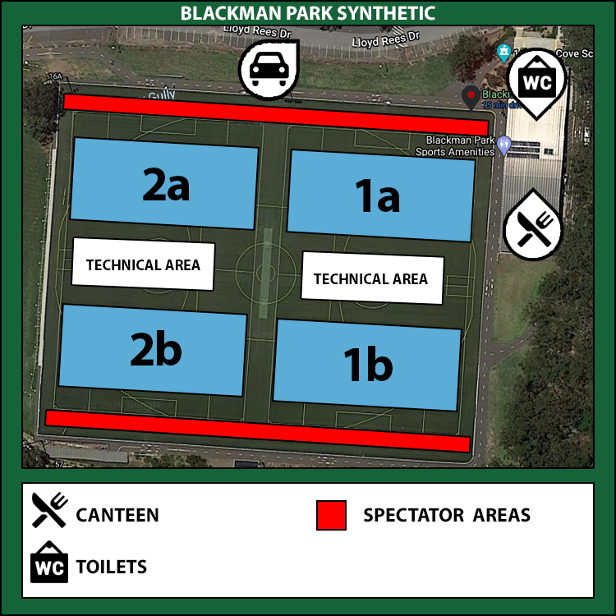

Full field dimensions | 100m x 64m
Midi field dimensions | 64m x 42m
Goal type | Portable goals – Bownets
Club responsible | Lane Cove FC

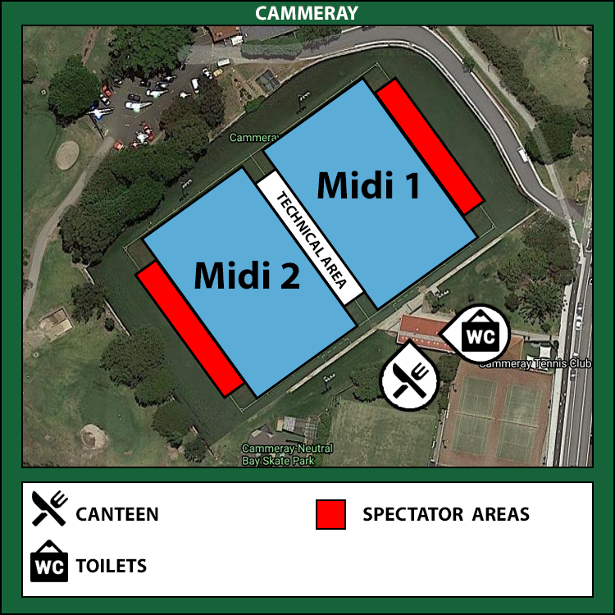

Full field dimensions | 98m x 63m
Midi field dimensions | 63m x 41m
Goal type | Portable goals – Bownets
Club responsible | North Sydney Utd FC

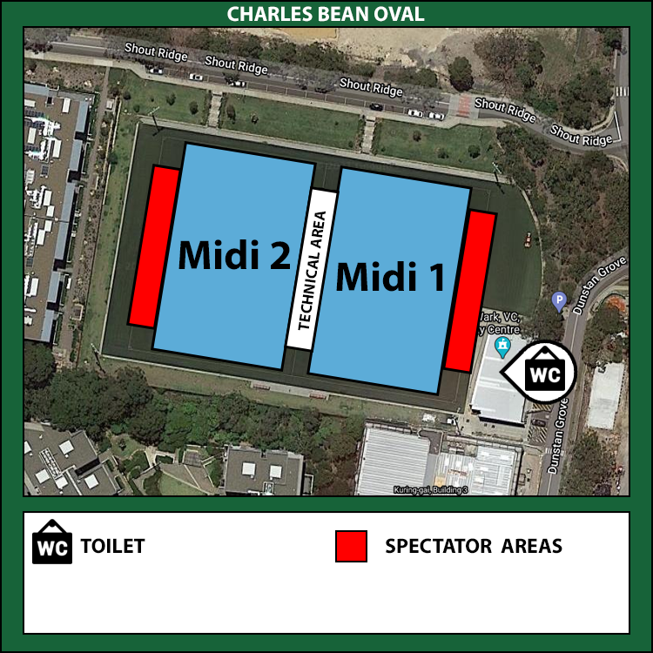

Full field dimensions | 100m x 68m
Midi field dimensions | 68m x 42m
Goal type | Portable goals – Bownets
Club responsible | Lindfield FC

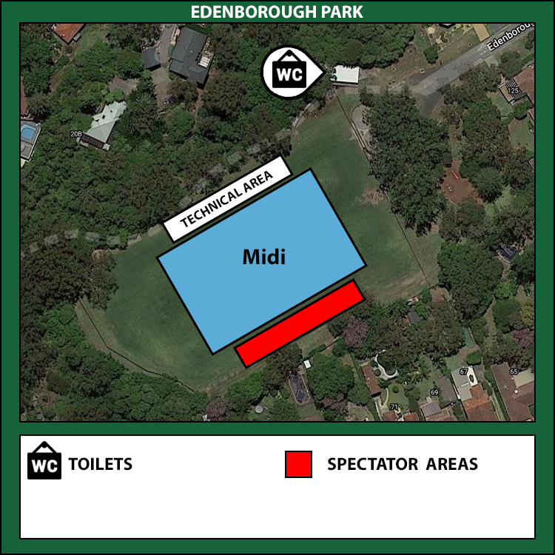

Full field dimensions | 91m x 56m
Midi field dimensions | 65m x 45m
Goal type | Permanent goals
Club responsible | Council (lines marked)

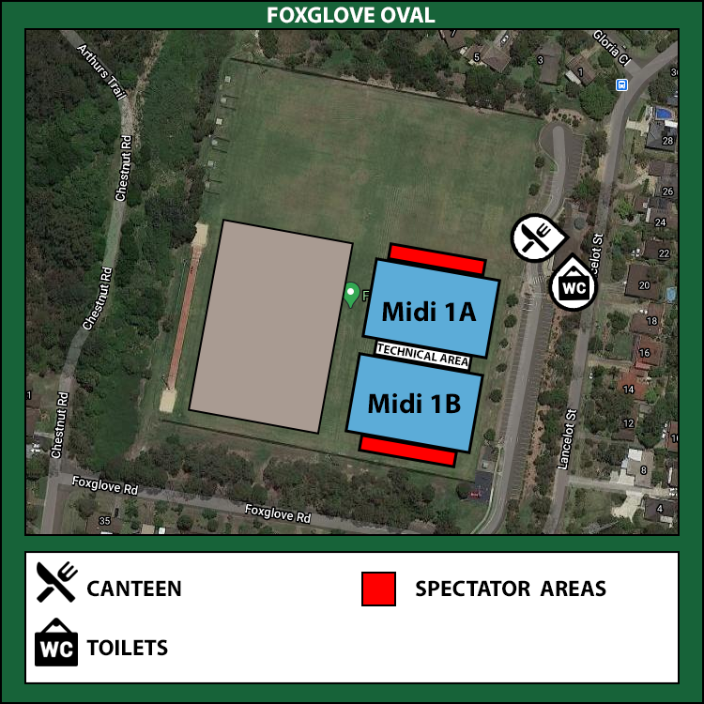

Full field dimensions | 104m x 67m
Midi field dimensions | 67m x 45m
Goal type | Portable goals – Bownets
Club responsible | Mount Colah FC

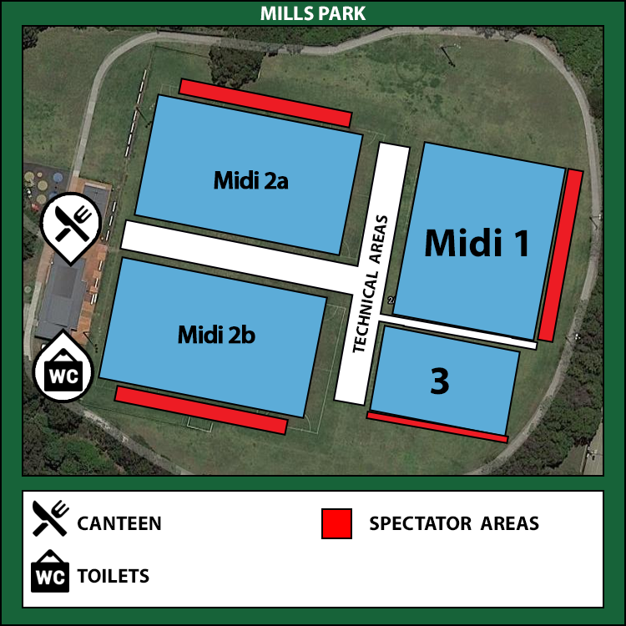

Full field dimensions | 100m x 75m
Midi field dimensions | 65m x 42m
Goal type | Portable goals – Bownets
Club responsible | Hornsby RSL FC

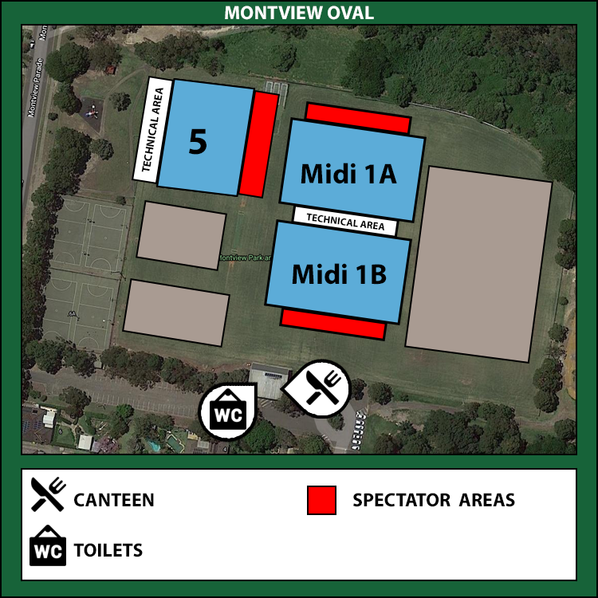

Full field dimensions | 101m x 71m
Midi field dimensions | 69m x 42m
Goal type | Portable goals – Bownets
Club responsible | Hornsby Heights FC
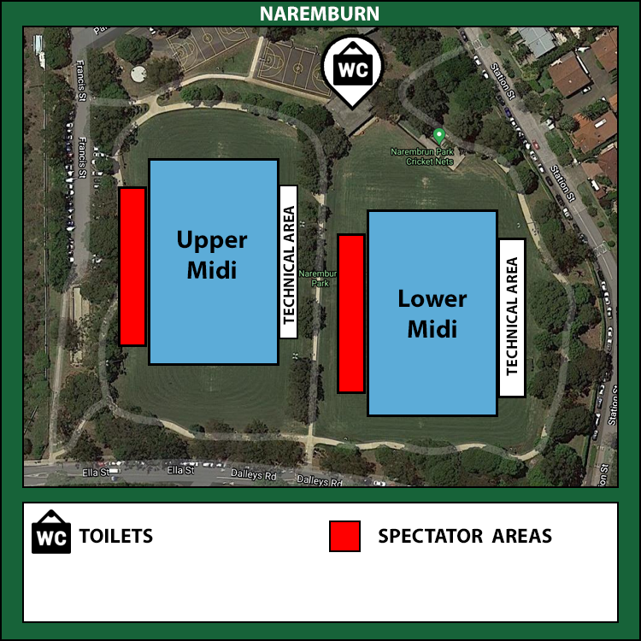

Full field dimensions | 98m x 64m
Midi field dimensions | 66m x 45m (box to box)
Goal type | Portable goals – Bownets
Club responsible | Northbridge FC

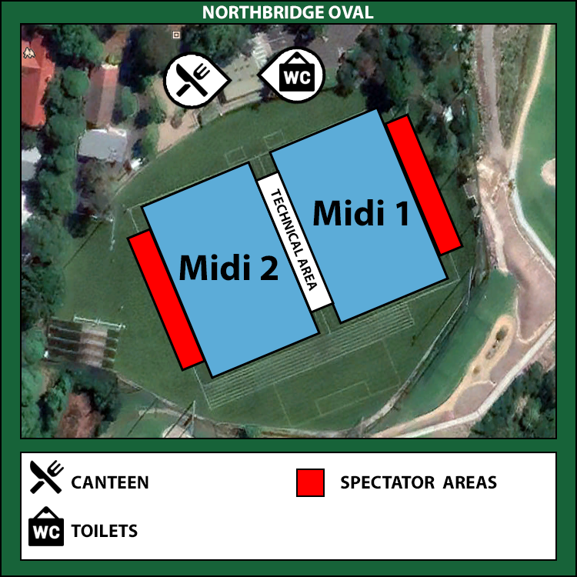

Full field dimensions | 94m x 67m
Midi field dimensions | 67m x 40m
Goal type | Portable goals – Bownets
Club responsible | Northbridge FC

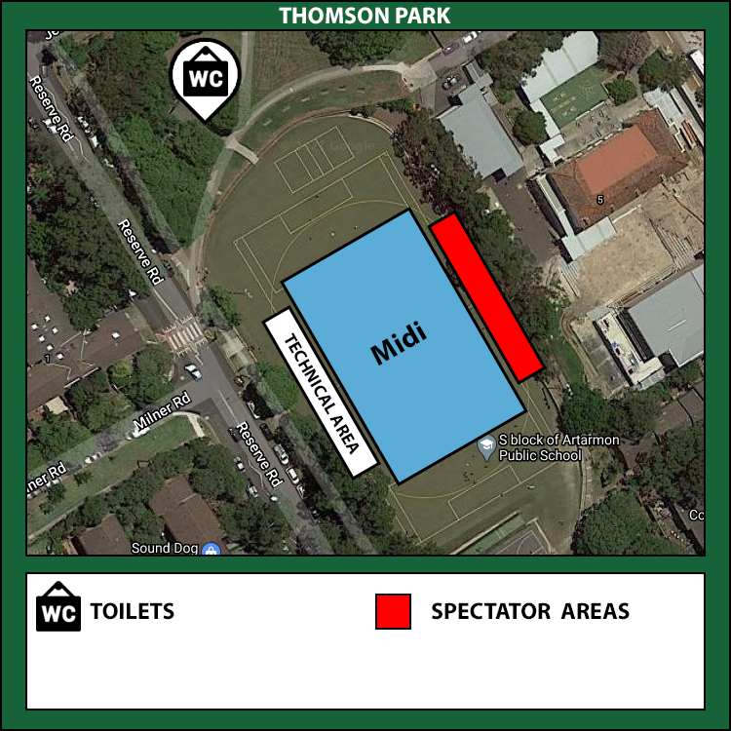

Full field dimensions | 90m x 45m
Midi field dimensions | 65m x 45m
Goal type | Portable goals – Bownets
Club responsible | Chatswood Rangers FC

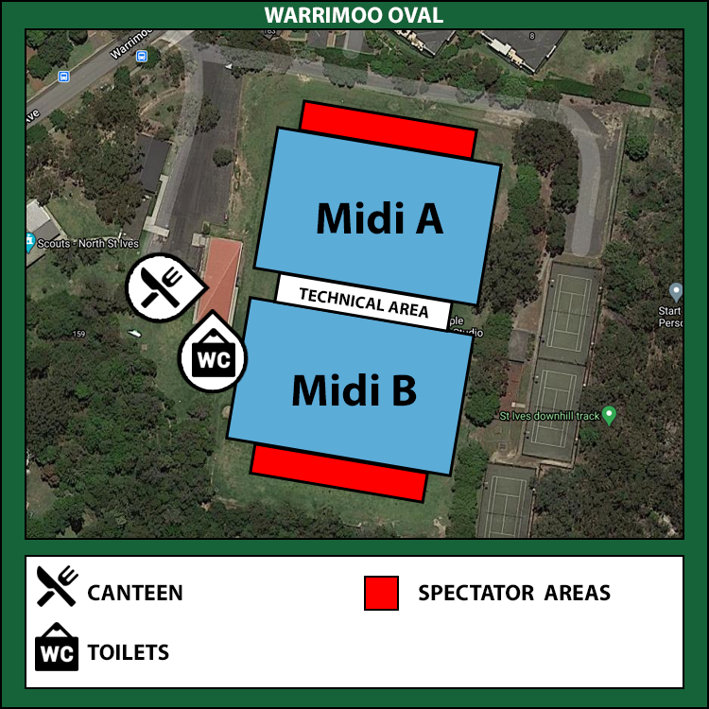

Full field dimensions | 100m x 67m
Midi field dimensions | 67m x 42m
Goal type | Portable goals – Bownets
Club responsible | St Ives FC

